Name:Aamir Kamal
ID: BC200415714
Question No. 1

The driver of a 2.0 × 10³ kg red car traveling on the highway at 45m/s slams on his brakes to avoid striking a second yellow car in front of him, which had come to rest because of blocking ahead as shown in above Fig. After the brakes are applied, a constant friction force of 7.5 × 10³ N acts on the car. Ignore air resistance.
Answer
- Determine the least distance should the brakes be applied to avoid a collision with the other vehicle?

Solution
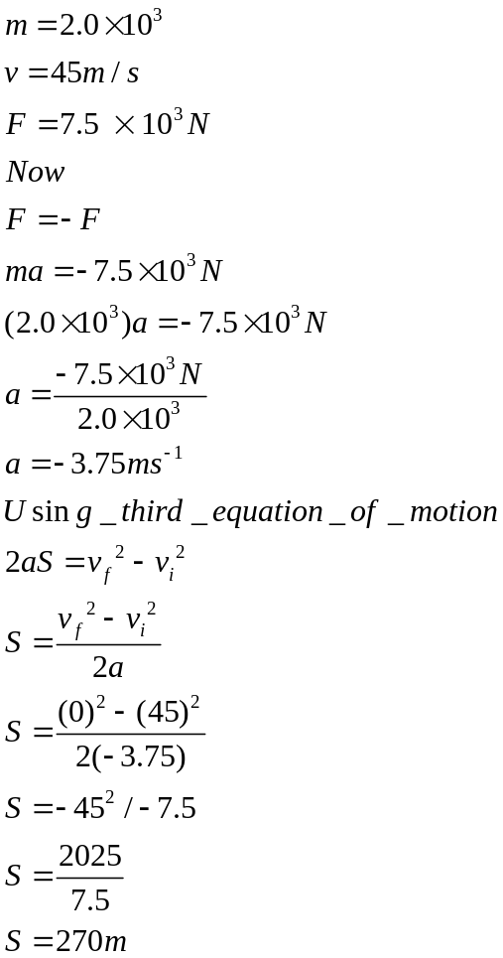
2. If the distance between the vehicles is initially only 40.0 m, at what speed would the collision occur?
Solution

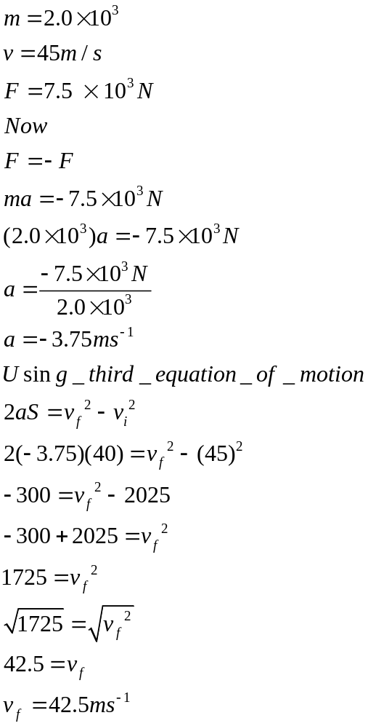
3. Write your conclusive observations on the result obtained from this numerical. i.e. the importance of Physics in daily life.

Answer

Physics runs in our daily lives and is involved in the myriad activities we perform and the things we use in our daily lives. As in the example above, if we know how far we should stay away from the yellow car to avoid an accident, we will adjust our speed. This can help us avoid accidents of any kind.

Question no 2
Consider an automobile moving at v mph that skids d feet after its brakes lock. Calculate how far it would skid if it was moving at 2v and the brakes were locked.

Solution




